# SQL ASSIGNMENTS

**Question 1 and 2:** Create a table called ‘employee’ that contains six columns:Empid,EmpName,Department,ContactNo,EmailId and EmpHeadIdail

Query and Output

CREATE TABLE Employee ( Empid int,EmpName varchar(20),Department varchar(20),ContactNo bigint,EmailId varchar(20),EmpHeadId int)

INSERT INTO Employee VALUES (101,'ISHA','E-101',1234567890,'isha@yahoo.com',105)

INSERT INTO Employee VALUES (102,'PRIYA','E-104',1234567890,'priya@yahoo.com',103)

INSERT INTO Employee VALUES (103,'NEHA','E-101',1234567890,'neha@yahoo.com',101)

INSERT INTO Employee VALUES (104,'RAHUL','E-102',1234567890,'rahul@yahoo.com',105)

INSERT INTO Employee VALUES(105,'ABHISHEK','E101',1234567890,'abhishek@yahoo.com',102)

SELECT * FROM Employee

## 

2)print the below details in the table

A)

SELECT * FROM Employee WHERE EmpHeadId >103



B)

SELECT * FROM Employee WHERE EmpHeadId>=103

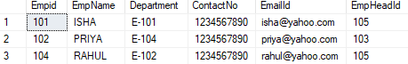

C)

SELECT * FROM Employee WHERE EmpHeadId<>105



D)

SELECT * FROM Employee WHERE EmpHeadId BETWEEN 101 AND 103

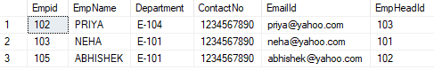

E)

SELECT * FROM Employee WHERE EmpheadId IN (105,102)

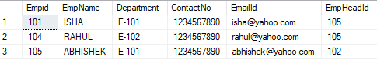

F)

SELECT * FROM Employee WHERE EmpName='PRIYA' OR Department='E-104'



G)

SELECT * FROM Employee WHERE EmpName LIKE 'a%'



H)

SELECT * FROM Employee WHERE EmpName NOT LIKE 'a%'

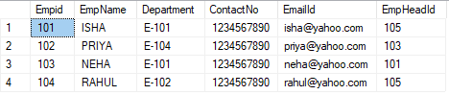

I)

SELECT * FROM Employee WHERE ContactNo IS NULL



J)

SELECT * FROM Employee WHERE EmpName LIKE '%k'



K)

SELECT * FROM Employee WHERE EmpName LIKE '%r%'



L)

SELECT * FROM Employee WHERE EmpName LIKE '_b%'



M)

SELECT * FROM Employee ORDER BY EmpHeadId ASC

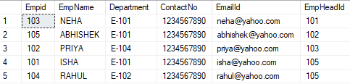

N)

SELECT * FROM Employee ORDER BY EmpHeadId DESC

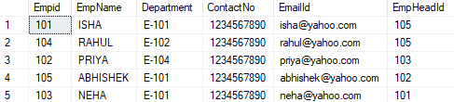

Question 3 : Create a table student and inert columns : studentid, name, email, password ,age, mark ,division and pass-fail

a) print all students whose age >23

b) print all students name who failed in the exam

c) print all details of student with id=100

d) print mark of the student with id =101

e) change the field name to pass_ fail to status

f) remove the column password

g) change values of all students age by adding 6

h) change everyone mark by decreasing 10

i) change the datatype of age into bigint

j) copy the table student into another table student1 and stud2

k) delete all the data of table student

l) drop all table student 2

m) print the all the values from students

Query and Output

create table studentt(studentid INT,namee VARCHAR(20),email VARCHAR (20),paswd VARCHAR(20),age INT,mark INT,divsion VARCHAR(10),pass_fail VARCHAR(20))

INSERT INTO studentt VALUES (100,'Rohit','rohit@gmail.com','abc123',25,43,'I','pass')

INSERT INTO studentt VALUES(101,'Reshma','reshma@gmail.com','def456',23,40,'II','pass')

INSERT INTO studentt VALUES (102,'Hari','hari@gmail.com','ghi789',26,35,'I','fail')

INSERT INTO studentt VALUES (103,'Amal','amal@gmail.com','jkl123',22,48,'II','pass')

INSERT INTO studentt VALUES (104,'Malu','malu@gmail.com','mno456',21,45,'II','pass')

INSERT INTO studentt VALUES (105,'Sooraj','sooraj@gmail.com','pqr789',24,50,'I','pass')

INSERT INTO studentt VALUES (106,'Anu','anu@gmail.com','stu123',20,32,'II','fail')

INSERT INTO studentt VALUES (107,'Rupa','rupa@gmail.com','vwx456',25,33,'I','fail')

1)

select * from student

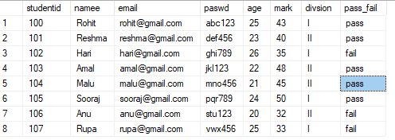

2)

select * from studentt where age > 23

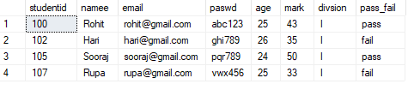

3)

select namee from studentt where pass_fail = 'Fail'

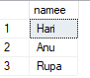

4)

select * from studentt where studentid = 100



5)

select mark from studentt where studentid = 101



6)

sp_rename 'studentt.pass_fail','status','column'

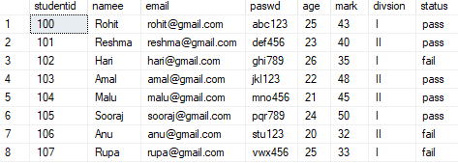

7)

alter table studentt drop column paswd

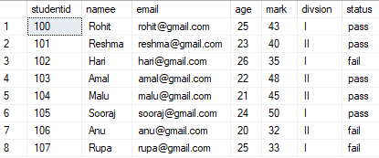

8)

update studentt set age+=6

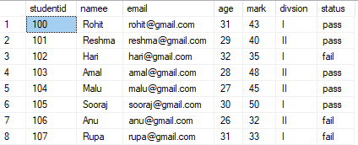

9)

update student set mark-=10

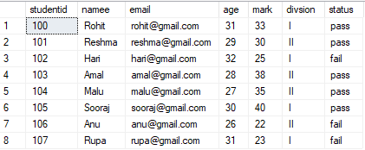

10) alter table studentt alter column age bigint

sp_help studentt

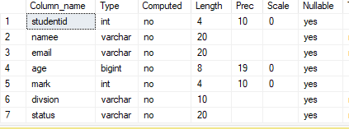

11) a) select * into student1s from student

select * from student

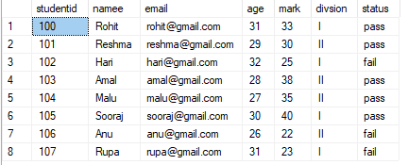

b) select * into student2s from studentt

select * from studentt

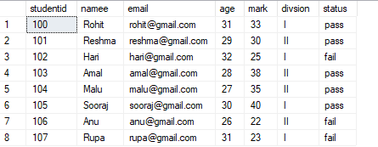

12)

DELETE FROM student



13)

DROP TABLE student2s



**Question 4**: Create two table Student Table and Fee Table and find out inner join, right join, full join and left join

Query and Output

create table StudentTable(AdmissionNo int,Firstname varchar(20),Lastname varchar (20),age int )

create table FeeTable(AdmissionNo int ,Course varchar(20),Amount_paid int)

insert into StudentTable values (3380,'Joel','John',15),(3410,'Japheth','Becky',16),(3398,'George','Joshuva',14)

insert into StudentTable values(3386,'John','Lucky',15),(3403,'Simon','Dan',13),(3400,'Calton','Becham',16),(3450,'Nicholas','Samuvel',14)

insert into FeeTable values(3380,'Electrical',20000),(3420,'ICT',15000),(3398,'Commerce',13000),(3410,'HR',12000)

1. select * from StudentTable

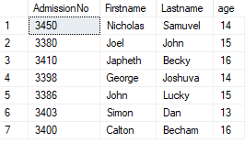

1. select * from FeeTable

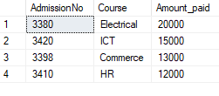

1. select StudentTable.Firstname,StudentTable.Lastname,FeeTable.Amount_paid from StudentTable left join FeeTable on StudentTable.AdmissionNo=FeeTable.AdmissionNo

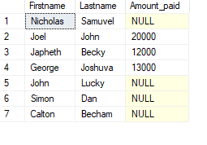

1. select StudentTable.Firstname,StudentTable.Lastname,FeeTable.Amount_paid from StudentTable inner join FeeTable on StudentTable.AdmissionNo=FeeTable.AdmissionNo

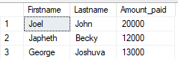

1. select StudentTable.Firstname,StudentTable.Lastname,FeeTable.Amount_paid from StudentTable right join FeeTable on StudentTable.AdmissionNo=FeeTable.AdmissionNo

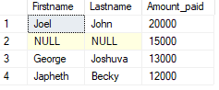

D)select StudentTable.Firstname,StudentTable.Lastname,FeeTable.Amount_paid from

StudentTable full join FeeTable on StudentTable.AdmissionNo=FeeTable.AdmissionNo

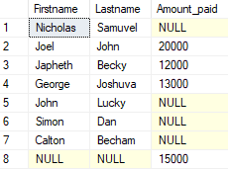

**Question 5:** Create two table Employee and EmployeeSalary

Print below details

Query and Outputs

create table employeee(Empid int primary key ,empname varchar(50) not null,department varchar(60) not null,contactno bigint unique,emailid varchar(100))

create table empsalary(Empid int ,salary int not null ,permanent varchar(3))

insert into employeee values(101,'ALAN','HR',9078563412,'alan@gmail.com'),(102,'SOORAJ','MANAGER',9988777661,'sooraj@gmail.com'),(103,'EVA','MANAGER',9087654321,'eva@gmail.com')

insert into employeee values(104,'ANU','HR',8877668945,'anu@gmail.com'),(105,'JESSI','MANAGER',6754347890,'jessi@gmail.com'),(106,'VARSHA','DEVELOPMENT',7865478950,'varsha@gmail.com')

insert into employeee values(107,'JOEL','DEVELOPMENT',7648912355,'joel@gmail.com')

insert into employeee values(108,'ROSE','DEVELOPMENT',8790675434,'rose@yahoo.com'),(109,'AMALU','HR',7845980325,'amalu@yahoo.com')

insert into empsalary values(101,50000,'Yes'),(102,55000,'Yes'),(103,75000,'No'),(104,35000,'Yes'),(105,47000,'No'),(106,67000,'Yes'),(107,58000,'No')

insert into empsalary values(108,64000,'Yes'),(109,32890,'No')

select * from employeee

select * from empsalary

1. select count(salary) as count from empsalary where permanent='yes' and salary>50000



1. select * from employeee where emailid like '%@gmail.com'

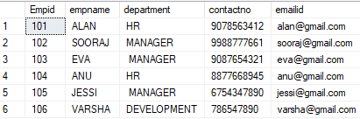

1. select * from employeee where department='HR' or department= 'department'

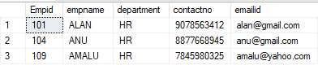

1. select sum(salary) from empsalary where permanent='Yes'



1. select * from employeee where empname like '_%a'



Question 6: Create a table using constraints

Query and Output

create table room( roomid int primary key ,availble Bit default 1,roomtype varchar(50) check(roomtype in ('single','double','deluxe')),dailyrent int default 1000)

create table B_D(Bookingid int primary key,roomid int foreign key references room(roomid),Customername varchar(50) not null,Fromdate datetime default ('currentdate'),Todate datetime not null,phoneno bigint check (len(phoneno)=10) unique)

insert into room values(101,3,'single',600),(102,4,'double',720),(108,2,'deluxe',1000),(104,1,'single',680)

insert into B_D values (11,101,'rohan','2002-02-02','2002-02-04',9078563412)

insert into B_D values (12,102,'meera','2020-06-24','2020-06-30',8877665544)

insert into B_D values (13,108,'rishi','2024-04-15','2024-04-20',9846345672)

insert into B_D values (14,104,'riya','2023-08-30','2023-09-01',8900035356)

1. select * from room

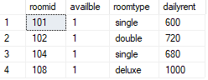

1. select * from B_D

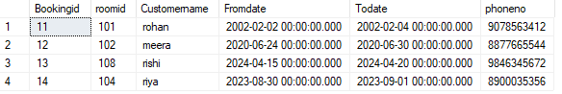

Question 7 : Create a table and find the sum

Query and Output

create table Employees ( slno int ,names varchar(20),salary int age int)

insert into Employees values(1,'Harish',2000,19),(2,'Dhanaraj',3000,20),(3,'Ashish',1500,19),(4,'Harish',1500,19),(5,'Ashish',1500,19)

select * from Employees

select sum(salary) as salarysum,names from Employees group by names

